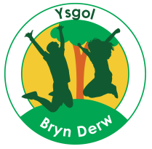
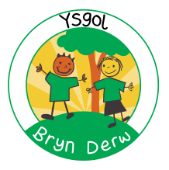

YSGOL BRYN DERW
GOVERNORS
ANNUAL REPORT TO PARENTS
2017 – 2018
FULL REPORT

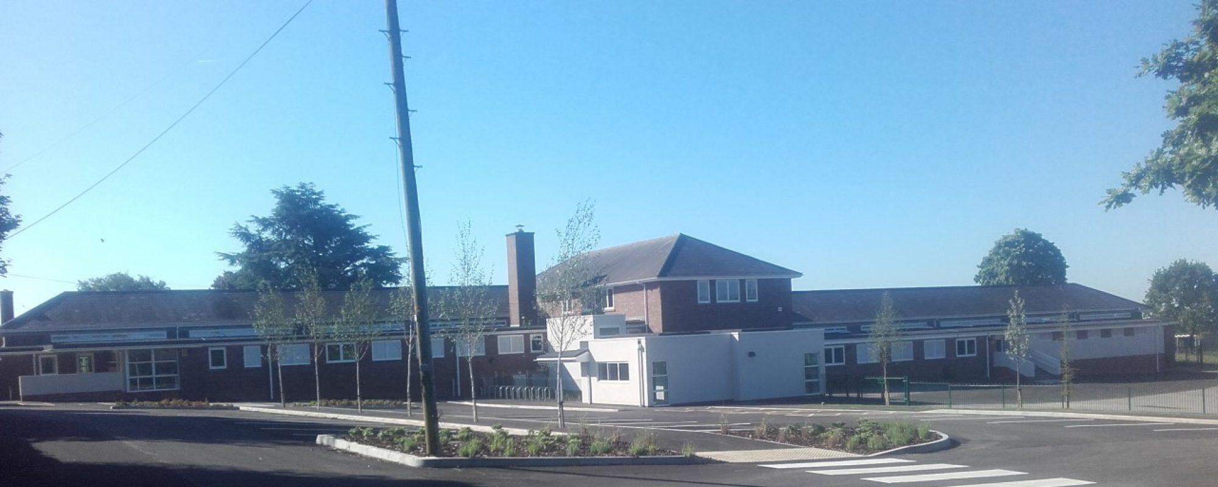

YSGOL BRYN DERW
MELFORT ROAD
NEWPORT
NP20 3FQ

01633 414988

ysgol.brynderw@newport.gov.uk

@YsgolBrynDerw17

Dear Parents/Carers
I am very pleased to be able to write this letter to accompany the very first Annual Report to Parents for Ysgol Bryn Derw.
I am extremely proud to be the Chair of Governors of this newly established, successful school, with a very hard-working, dedicated, talented staff team and a skilled, committed team of Governor colleagues.
As a full Governing Body we meet on a Wednesday evening every half term and the two sub committees meet termly so that any discussions and decisions can provide information for the full meeting on a regular basis. I thank all my Governor colleagues for the time and expertise they provide to the school, not only in the formal meetings but through the extra support they provide both to the strategic development and informal activities.
You will be aware of the many exciting developments and successes that all of the children have been able to experience in their first year at Ysgol Bryn Derw and this report provides further information on these areas and the key work of the Governing Body.
Finally, I would like to thank you all, parents, grandparents and carers. Your support and input to the school in so many ways ensures the continuing success of the happy, exciting learning environment of Ysgol Bryn Derw.
Best Wishes,

Paula Halsall
Chair of Governors

YSGOL BRYN DERW – GOVERNORS ANNUAL REPORT TO PARENTS 2017-18

- (& B.)
This is the first Governors Annual Report to Parent. No petition for an annual parents’ meeting with Governors was received during the year, and so no meeting was held under Section 94 of the School Standards and Organisation (Wales) Act 2013.

The Governing Body consists of:

Name | Category of Governor | End of term of office
Paula Halsall | Local Authority | 26/9/21
Katy Rees | Local Authority | 26/9/21
Shirley Egley | Community | 16/10/21
Emma Curtin | Community | 16/10/21
Leanne Coleman | Parent (Elected) | 9/10/21
Nikki Chard | Parent (Elected) | 9/10/21
Gwen Vaughan | Parent (Elected) | 9/10/21
Abby Vowles | Teacher (Elected) | 9/10/21
Kate Drew | Staff (Elected) | 9/10/21
Richard Drew | Head Teacher | n/a

If you wish to contact the Governing Body, the relevant contact details are:

Chair of Governors – Paula Halsall, care of: Ysgol Bryn Derw, Melfort Road, Newport, NP20 3FQ
Clerk to the Governing Body – Vicky Dench, care of: Ysgol Bryn Derw, Melfort Road, Newport, NP20 3FQ

There are no current vacancies for Parent Governors. If a vacancy arises, all parents/carers will be contacted to inform them and to invite them to stand for election.

Section 52 Statement:

 |  | Ysgol Bryn Derw
 | Financial Statement for Year Ending 31st March 2018
 | 2016/17 |  | 2017/18
 | Outturn |  | Outturn
 | £ | Employees | £
 | 0 | Teachers | 187,239
 | 0 | Support Staff | 215,479
 | 0 | Caretakers | 24,762
 | 0 | Midday Supervisors | 0
 | 0 | Cleaners | 0
 |  | Other Employee Costs
 | 0 | Supply Insurance Premium | 0
 | 0 | Agency Staff | 10,098
 | 0 | Lunch Time Meal Entitlement | 0
 | 0 | Foreign Language Assistants | 0
 | 0 | Exam Invigilators | 0
 | 0 | Advertising | 1,015
 | 0 | Interview Expenses | 77
 | 0 | Misc Employee Costs | 250
 |  | Energy
 | 0 | Gas | 4,631
 | 0 | Electricity | 2,274
 | 0 | Oil | 0
 | 0 | Capitation and ICT | 38,347
 | 0 | SCC, EIG and PDG Expenditure | 14,780
 |  | Premises Related
 | 0 | Hire of Facilities | 0
 | 0 | Rates | 0
 | 0 | Building Maintenance and Alarm Lines | 19,859
 | 0 | Grounds Maintenance | 1,052
 | 0 | Water | 1,412
 | 0 | Building Cleaning Contract | 423
 | 0 | Refuse Collection | 421
 | 0 | Miscellaneous Premises | 8,080
 |  | Communications
 | 0 | Postage/Fax/Telex | 149
 | 0 | Telephones | 0
 |  | Transport
 | 0 | Vehicle Maintenance | 300
 | 0 | Vehicle Hire | 78
 | 0 | Car Allowance | 286
 | 0 | Travel Expenses | 0
 | 0 | Exam Fees | 0
 |  | External Courses
 | 0 | School Funded Training | 8,703
 | 0 | Sixth Form | 0
 | 0 | Central Services | 6,550
 |  | Income
 | 0 | Lettings | 0
 | 0 | Sales Income | -1,000
 | 0 | Music Service Income | 0
 | 0 | Donations | -24,934
 | 0 | Miscellaneous | 0
 | 0 | Supply | 0
 | 0 | Exam Fees | 0
 | 0 | Interest | 0
 | 0 | Rental Income | 0
 | 0 | EIG | -14,151
 | 0 | PDG/EYPDG | 0
 | 0 | Energy Compensation | 0
 | 0 | Coaching Fees | 0
 | 0 | Other Grant and Contributions | -25,097
 | 0 | After Schools Club | 0
 | 0 | Total Net Expenditure | 481,083
 | 0 | Total Funding | 602,608
 | 0 | Current Surplus / Deficit for Year | 121,525
 | 0 | Previous Year's Surplus / Deficit | 0
 | 0 | Accumulated Surplus / Deficit c/fwd | 121,525
 | 0.00% | Balance as % of Funding | 20.17%

The total funding received in 2017-18 was £667,790, made up of a £602,608 budget share allocated by NCC, and £65,182 in Welsh Government grants, donations from parents and businesses, and one very large charitable donation from an Autism charity. The budget was spent as follows:
Approximately 64% of the budget was spent on staffing costs (£427,480 in total).
Approximately 1.5% of the budget was spent on supply staff, to cover ad hoc staff sickness, and planned staff absences due to training courses.
Nearly 6% of the budget (£38,347) was spent on supplying the school with the required furniture and equipment, general classroom and stationery supplies, ICT equipment (such as laptops, iPads, iPods and some required ICT licences), and photocopier charges.
5% of the budget (£31,247) was spent on premises related costs, including: repairs and general maintenance; insurance and required licences; cleaning and hygiene supplies; improvements to the security system; work carried out by Newport Norse in preparation for school opening (e.g. carpet tiles in all classrooms, line painting in the carpark and playgrounds, and the installation of showers in all hygiene bathrooms).
Approximately 1% (£6905) of the budget was spent on energy costs.
Approximately 1.3% (£8703) of the budget was spent on staff training (e.g. Rebound Therapy, PECS, Read Write Inc., ELKLAN and Thrive).
Almost 1% of the budget was allocated to required Service Level Agreements with Newport City Council (e.g. Finance, HR, Legal Services, and Health and Safety).
A 20% surplus (£121,525) was carried forward to accommodate rising pupil numbers and associated staffing and equipment costs in 2018-19.
We did not receive any gifts in 2017-18 (aside from monetary donations listed above).
No travel and subsistence claims were made by members of the Governing Body in 2017-18.

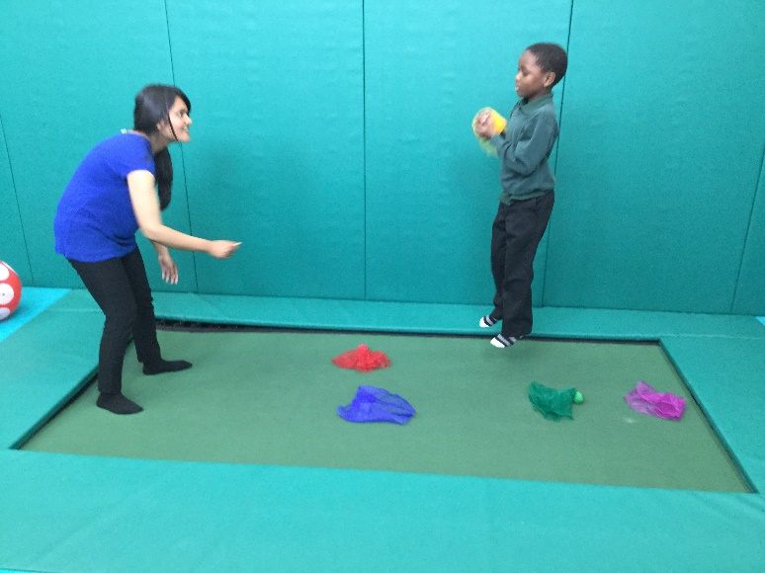

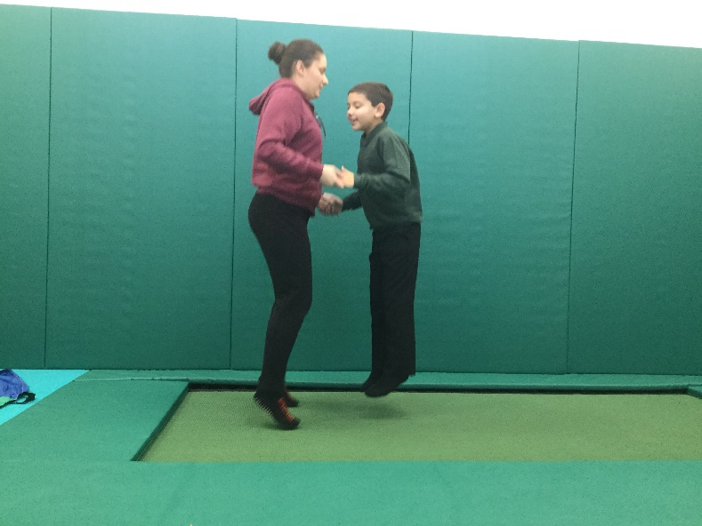

End of Key Stage outcomes data for English and Maths (Years 2, 6 & 9):

English:
Key Stage | Working towards Outcome 1 | Outcome 1 | Outcome 2 | Outcome 3 | Number of pupils
Foundation Phase | 4 | 1 | 1 | 0 | 6

Key Stage | Working towards Level 1 | NC  Level 1 | NC  Level 2 | NC  Level 3 | Number of pupils
KS2 | 1 | 1 | 0 | 0 | 2
KS3 | 1 | 0 | 0 | 0 | 1

Maths:
Key Stage | Working towards Outcome 1 | Outcome 1 | Outcome 2 | Outcome 3 | Number of pupils
Foundation Phase | 3 | 2 | 1 | 0 | 6

Key Stage | Working towards Level 1 | NC  Level 1 | NC  Level 2 | NC  Level 3 | Number of pupils
KS2 | 1 | 1 | 0 | 0 | 2
KS3 | 1 | 0 | 0 | 0 | 1

Annual Attendance and absence figures for the school. Our attendance target was 90.9%:

Type of entry | Present | Holiday | Illness | Medical | Other authorised | Unauthorised
Percentage  2017-18 | 94.0% | 1.2% | 3.6% | 0.4% | 0.1% | 0.6%

There were no Year 11 pupils in 2017-18, so there is no relevant information on destinations for Year 11 pupils.

The school has growing links with the Community which have brought considerable benefits to pupils and helped them to develop their communication, interaction and independence. Links include:
  - Visits to Local Doctor’s Surgery
  - Visits from St John’s Ambulance, Fire Service, Police Dog Service
  - Visits from professional partners including Speech and Language Therapists, Occupational Therapists, Learning Disability Nurses, Educational Psychologists, Counsellors and Music Therapists
  - Visits from our Welsh Assembly Member for Newport West and from Newport City Councillors
  - Shopping at Local Shops, Tesco
  - Visits to Stelvio Park
  - Barry Island Rotary Club activity days
  - Gaer Primary School for inclusive partnerships
  - Leckwith Stadium for WSAPLD Athletics competitions
  - Entry to Welsh Schools Heritage Initiative competition
  - Spytty Park for Tennis taster sessions
  - Risca Leisure Centre for swimming
  - Newport Wetlands

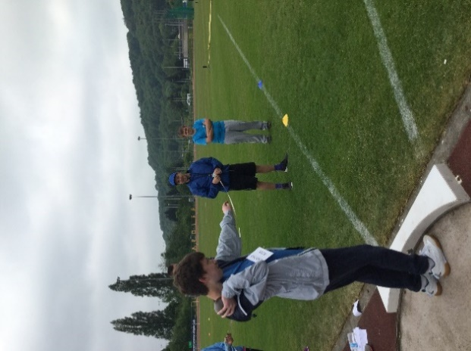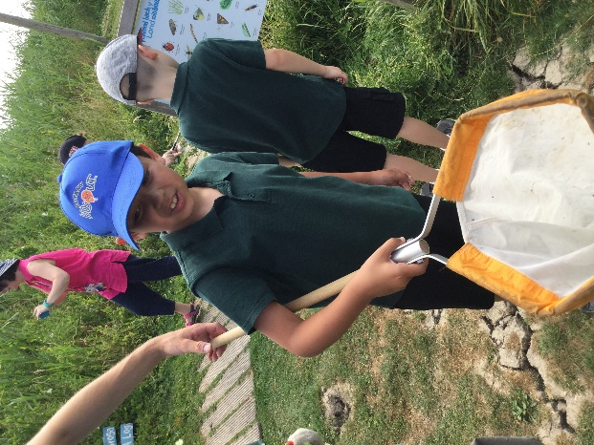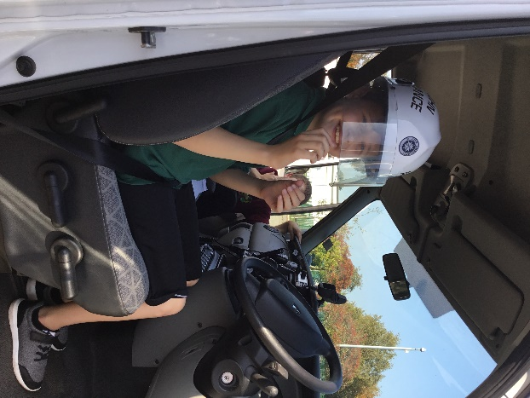

Targets for attendance for 2018-19 have been set, and include targeting further increases in attendance:
 | 2018-19 targets
Overall | 94.5%
Primary | 94%
Secondary | 96%

The key foci of the School Development Plan for 2018-19 have been agreed and are:
- To ensure pupils with English as an Additional Language perform was well as their English first language peers
- Pupils to show expected or above expected progress in ASD related skill areas
- To ensure that all KS3/4 pupils achieve individually appropriate accredited results
- To increase level of successful purposeful pupil interactions with peers and adults in other classes and in the community
- Engagement levels and positive attitudes to learning will be enhanced
- All learning experiences will be good or better
- To ensure all pupils make strong progress in relation to their personal profile and journey
- Incidental Welsh opportunities to be embedded across all classes in daily pupil experiences
- Maximising impact of enhanced interventions
- To develop role of pupils as ethical, informed citizens by developing their decision making skills
- To increase value for money and reduce fixed costs
- Increase involvement of the whole staff team in school self-evaluation
- Develop staff awareness of the new Successful Futures Curriculum and Professional Learning offer

Physical Education is an important aspect of the curriculum and experience for all pupils. PE and sporting activities are designed to develop the following:
- Improved Fine and Gross Motor Skills
- Increased self-confidence and self-esteem
- Improved skills in listening and following instructions
- Positive attitudes to health and exercise
- Mature approaches to competition and to winning and losing
All pupils participate in specially designed PE lessons every week. All pupils have access to Rebound Therapy with specially trained staff each week. All pupils had opportunities to participate in Sports Day held on June 22nd. Swimming lessons were arranged in the second half of 2017-18 and attended by classes 6, 7 & 8. Older pupils have also competed in heats and finals with the Welsh Sports Association for People with Learning Difficulties.

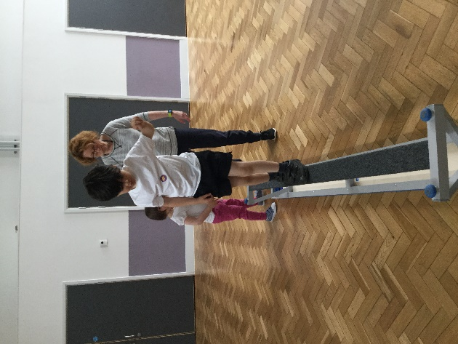

The following policies were adopted by the Governing Body in 2017-18, and are available on the school website (www.ysgolbrynderw.co.uk):

- Accreditation
- Administration of medication
- Anti-bullying
- Assessment
- Attendance
- Bullying and harassment
- Charging
- Code of conduct
- Collective worship
- CPD
- Disciplinary
- Display
- Family friendly
- Food & fitness
- Grievance
- Health & Safety
- Homework
- Intimate care
- Leave of absence
- Management of attendance
- Marking
- Parent partnership
- Pay and reward
- Teachers Pay policy
- Performance Management
- Photography at school events
- Positive behaviour management
- Positive Touch
- Probationary
- Recruitment
- Safeguarding
- School uniform
- Sex and relationships education
- SEN
- Staff dress code
- Subject allocation
- Teaching & learning
- Use of reasonable force
- Whistle-blowing
- Whole school curriculum
- Work-life balance

The pupils arrive at Ysgol Bryn Derw, either with families or on Local AuthorityTransport accompanied by experienced escorts, by 8.55am. They proceed, or are taken by school staff to their classrooms where their teachers are in the classrooms ready to receive them. After the pupils have all been taken to their classrooms, the structure for each school day is as follows:-
9.00 Registration
9.05 Lessons commence
10.30 Break
10.45 Lessons continue
12.00 Lunch
1.00 Lessons continue
3.15 End of School Day
(Pupils transported home – families or Local Authority Transport)

The term dates set by Newport City Council are as follows:

Term | Term Begins | Half Term Begins | Half Term Ends | Term Ends
Autumn | Monday  3rd September 2018 | Monday  29thOctober 2018 | Friday  2nd November 2018 | Friday  21st December 2018
Spring | Monday  7th January 2019 | Monday  25th February 2019 | Friday  1st March 2019 | Friday  12th April 2019
Summer | Monday  29th April 2019 | Monday  27th May 2019 | Friday  31st May 2019 | Monday  22nd July 2019

May Day – Monday 5th May 2019

There will be 5 closure days for staff In-Service Training (INSET days):

Monday 3rd September 2018  Tuesday 4th September 2018  Friday 12th October 2018  Monday 7th January 2019  Monday 22nd July 2019  (Decoupled for 3 x 2 hour Twilight Sessions) | Person Centred Planning  (+ Food hygiene)  SAFEGUARDING: Child Protection, Prevent, Health and Safety, Manual Handling  Numeracy approaches  Total Communication & ASD Approaches - Intensive Interaction  Teaching and learning developments and new initiatives | Internal staff group workshops ensuring all resources and environments are ready for pupil arrival  External agencies and internal staff deliver training to refresh staff core competencies and ensure all pupils’ needs are well met  External trainer sessions relating to numeracy strategies, followed by team planning and co-ordination  Focus on ASD supportive approaches with external expert sessions  Ensuring all staff are up-to-date with new developments and best practice to inform high quality teaching and learning

The first school prospectus is currently being developed

The School are committed to providing access to a broad curriculum for all of our pupils. Alongside this we recognise that the curriculum must be relevant to pupils’ individual needs and there must be in-built flexibility in order to ensure continued relevance for all pupils at the various stages of their time at Ysgol Bryn Derw. This will mean that not all of our pupils will experience all aspects of the curriculum all of the time, but rather that a balance in the whole curriculum will be reflected in pupils’ individual experiences according to the various age related stages of their school life. Balance across the curriculum will also be dictated by the diverse and complex individual needs of our pupils. We recognise that our pupils benefit from a wide variety of sensory activities and the many forms of therapy which are offered to them and that some of our pupils with very challenging behaviours will need an even greater degree of flexibility in their learning and social programmes.

In 2017-18 pupil numbers grew rapidly, and so the set of classes moved from 2 Foundation Phase, 1 KS2 and 1 KS3 class in September to 2 Foundation Phase, 2 KS2, 1 KS3 and 2 cross phase classes by the summer term.

All of our pupils where appropriate, have access to the full range of subjects in the National Curriculum Framework appropriate to their age provided in a way that matches the stage of their development.

The teaching experiences/activities provided and accompanying schemes of work reflect the programmes of study from Foundation Phase, KS2 and 3 of the National Curriculum and for KS4 & 5 accredited units and modules.

The language of the school is designated as English medium

All pupils experience Welsh as an additional language and have incidental Welsh opportunities throughout the school day. Pupils experience Welsh at a level appropriate to their academic and communication skills, and incidental opportunities include greetings, praise, days of the week, numbers, colours, body parts and weather. These will typically be used alongside the English term for the same word. The school has a number of fluent Welsh speaking staff and so is able to offer more sophisticated Welsh language interaction and learning to those who require it. No pupils are dis-applied from any subjects in the National Curriculum

The school has 4 hygiene bathrooms (2 on each corridor) with changing beds, toilets and showers. There are also 4 separate sets of toilet cubicles (2 on each corridor). All bathrooms and toilets are cleaned daily by Newport Norse and checked throughout the day by staff.

Healthy eating and drinking is an important aspect of the curriculum and experience of all pupils. The approach of the school to eating and drinking are designed to develop the following:
  - A broadened diet
  - Increased awareness of the impact of diet on health and the human body
  - Improved decision making skills
  - Positive attitudes to health and exercise
  - Increased independence in eating and drinking
The School achieved Level 1 of the Healthy Schools Award in 2017-18. To achieve progress in healthy eating and drinking the school take a ‘whole school/whole day’ approach to the provision of food and drink.

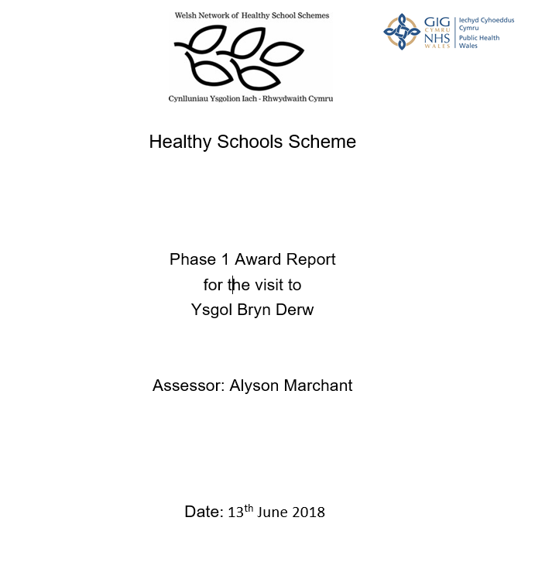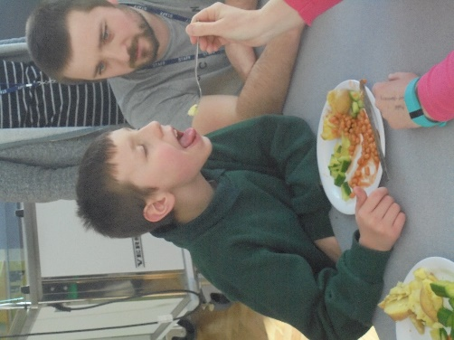

The school provide in partnership:
  - Healthy, nutritious, affordable and attractively presented meals in partnership with NCC catering department and Chartwells.
  - Breakfast Clubs, as far as possible, in line with Welsh Government guidance.
  - Healthy snacks at break times will be encouraged.
  - An enjoyable eating experience in a quality environment.
  - Encouragement for parents to provide healthy lunch boxes.
  - Fresh water, available to all staff and pupils in classrooms
  - Display materials within and around the school that promote the positive relationship between food and physical activity.
  - Engagement with pupils, where appropriate, on healthy food and fitness activities through vehicles such as School Councils (e.g. Fruit Tuck, Healthy Lunchbox etc.)
  - Procurement and menu planning that recognises the importance of purchasing locally, seasonality, and environmental sustainability in partnership with NCC catering department and Chartwells.

