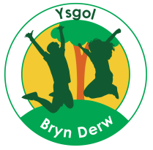
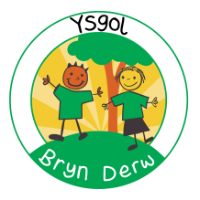

YSGOL BRYN DERW
GOVERNORS
ANNUAL REPORT TO PARENTS
2018 – 2019
FULL REPORT

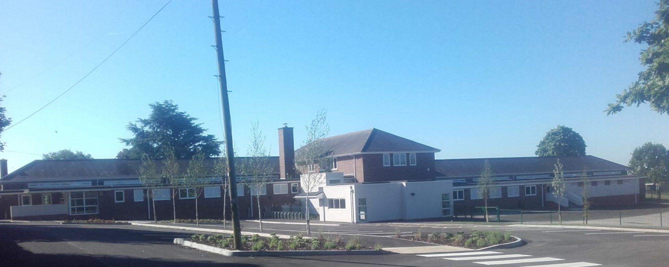

YSGOL BRYN DERW
MELFORT ROAD
NEWPORT
NP20 3FQ

01633 414988

ysgol.brynderw@newport.gov.uk

@YsgolBrynDerw17

Dear Parents/Carers
It is with great pleasure that I write this letter to accompany the second Annual Report for Parents of Ysgol Bryn Derw.
I am extremely proud to be the Chair of Governors for Ysgol Bryn Derw for a second year and enjoy being associated with the hard-working, dedicated, talented staff team and the skilled, committed group of Governors.
As a full Governing Body and two sub committees, we continue to meet on a Wednesday evening every half term, ensuring that the robust strategic development and school planning is effective in driving the school forward. Through appropriate challenge and discussion, the Governing Body oversees the smooth running and progression of the school and I thank all my Governor colleagues for the time and expertise they provide to the school for both formal and informal activities.
Following consultation on the refurbishment of the annexe building in the school grounds, I look forward to further exciting developments with the growth of the school in the next academic year. Once completed, this building will offer further opportunities for our older learners to become more independent and provide them with further positive experiences. You will find that this report provides further information about these changes and about the key work of the Governing Body.
Finally, I would like to thank all parents, grandparents, family and carers. Your continued support and input throughout the last year has ensured the ongoing success of the happy, exciting learning environment of Ysgol Bryn Derw.
Best Wishes,

Paula Halsall
Chair of Governors

YSGOL BRYN DERW – GOVERNORS ANNUAL REPORT TO PARENTS 2018-19

- (& B.)
This is the second Governors Annual Report to Parent. No petition for an annual parents’ meeting with Governors was received during the year, and so no meeting was held under Section 94 of the School Standards and Organisation (Wales) Act 2013.

The Governing Body consists of:

Name | Category of Governor | End of term of office
Paula Halsall | Local Authority | 26/9/21
Nathan Kethro | Local Authority | 11/9/22
Shirley Egley | Community | 16/10/21
Emma Anderson | Community | 16/10/21
Jenna Mellon | Parent (Elected) | 2/7/23
Nikki Chard | Parent (Elected) | 9/10/21
Gwen Vaughan | Parent (Elected) | 9/10/21
Abby Vowles | Teacher (Elected) | 9/10/21
Kate Drew | Staff (Elected) | 9/10/21
Richard Drew | Head Teacher | n/a

If you wish to contact the Governing Body, the relevant contact details are:

Chair of Governors – Paula Halsall, care of: Ysgol Bryn Derw, Melfort Road, Newport, NP20 3FQ
Clerk to the Governing Body – Joanne Howard, care of: Ysgol Bryn Derw, Melfort Road, Newport, NP20 3FQ

There are no current vacancies for Parent Governors. If a vacancy arises, all parents/carers will be contacted to inform them and to invite them to stand for election.

Section 52 Statement:
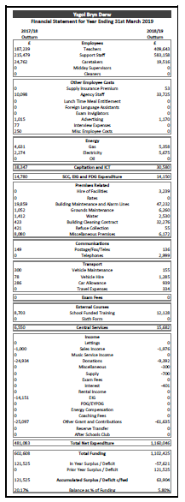

The total funding received in 2018-19 was £1,176,829, made up of a £1,102,425 budget share allocated by NCC, and £74,404 in Welsh Government grants, donations from parents and businesses, and income from training courses. The budget was spent as follows:
Approximately 85% of the budget was spent on staffing costs (£999,619 in total).
Approximately 2.9% of the budget was spent on supply staff, to cover ad hoc staff sickness, and planned staff absences due to training courses.
Nearly 2% of the budget (£23,190) was spent on supplying the school with the required furniture and equipment, general classroom and stationery supplies, ICT equipment (such as laptops, iPads, iPods and some required ICT licences), and photocopier charges.
8.7% of the budget was spent on premises related costs, including: repairs and general maintenance; insurance and required licences; cleaning and hygiene supplies; improvements to the security system; work carried out by Newport Norse to improve our environment.
Approximately 1% (£11,033) of the budget was spent on energy costs.
Approximately 1% (£12,128) of the budget was spent on staff training (e.g. Intensive Interaction, PECS, Attention Autism and TIS).
Approximately 1.3% of the budget was allocated to required Service Level Agreements with Newport City Council (e.g. Finance, HR, Legal Services, and Health and Safety).
A 5.8% surplus (£63,904) was carried forward to accommodate rising pupil numbers and associated staffing and equipment costs in 2019-20.
We did not receive any gifts in 2018-19 (aside from monetary donations listed above).
No travel and subsistence claims were made by members of the Governing Body in 2018-19.

End of Key Stage outcomes data for English and Maths (Years 2, 6 & 9):

English:
Key Stage | Working towards Outcome 1 | Outcome 1 | Outcome 2 | Outcome 3
Foundation Phase | 60% | 0% | 20% | 20%

Key Stage | Working towards Level 1 | NC  Level 1 | NC  Level 2 | NC  Level 3
KS2 | 75% | 25% | 0% | 0%
KS3 | 50% | 50% | 0% | 0%

Maths:
Key Stage | Working towards Outcome 1 | Outcome 1 | Outcome 2 | Outcome 3
Foundation Phase | 40% | 20% | 20% | 20%

Key Stage | Working towards Level 1 | NC  Level 1 | NC  Level 2 | NC  Level 3
KS2 | 50% | 25% | 25% | 0%
KS3 | 0% | 50% | 50% | 0%

Annual Attendance and absence figures for the school. Our attendance target was 94.5%:

Type of entry | Present | Holiday | Illness | Medical | Other authorised | Unauthorised
Percentage  2018-19 | 94.8% | 1.6% | 2.7% | 0.4% | 0.3% | 0.2%

There were no Year 11 pupils in 2018-19, so there is no relevant information on destinations for Year 11 pupils.

The school has growing links with the Community which have brought considerable benefits to pupils and helped them to develop their communication, interaction and independence. Links include:
  - Visits to local Baptist Church
  - Visit from Fire Service
  - Visits from professional partners including Speech and Language Therapists, Occupational Therapists, Learning Disability Nurses, Educational Psychologists, Counsellors and Music Therapists
  - Shopping at Local Shops, Tesco
  - Visits to Stelvio Park & Serennu Park
  - Gaer Primary School for inclusive partnerships
  - Participation in a Dance Festival
  - Visits to Theatre and Cinema
  - Visit to St Fagan’s Museum
  - Leckwith Stadium for WSAPLD Athletics competitions
  - Entry to Welsh Schools Heritage Initiative competition
  - Spytty Park for Tennis taster sessions
  - Risca Leisure Centre & NISV for swimming

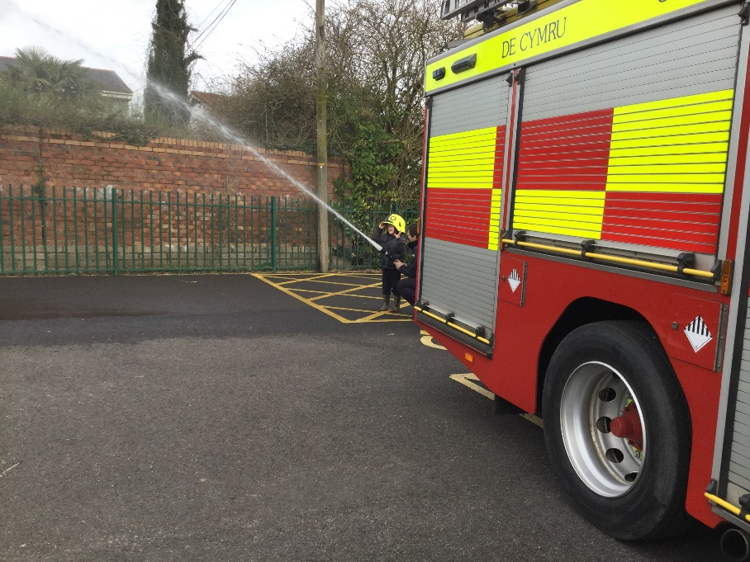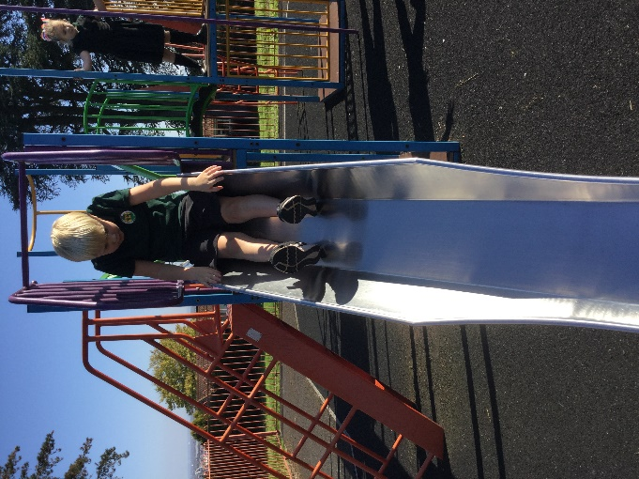

Targets for attendance for 2019-20 have been set:
 | 2019-20 targets
Overall | 93.8%
Primary | 93.8%
Secondary | 93.8%

The key foci of the School Development Plan for 2019-20 have been agreed and are:
- Maintain outcomes for vulnerable groups and improve outcomes in priority key skills
- Deliver relevant accredited opportunities for age appropriate learners
- Ensure that identified pupils make at least expected progress by embedding co-ordinated ACE plan that combines TIS and Thrive approaches
- Develop authentic outdoor learning experiences that embed and progress priority skill areas for each pupil
- Develop multi-agency working to maximise impact of staff and professionals in all areas of challenge for pupils and families
- Ensure Annex building is resourced and equipped at a level equivalent to main building and is equipped in a bespoke approach to post-14 curriculum
- Provide tailored professional learning for all practitioners in key areas of national priority (e.g. Curriculum for Wales, new Professional Standards)

Physical Education is an important aspect of the curriculum and experience for all pupils. PE and sporting activities are designed to develop the following:
- Improved Fine and Gross Motor Skills
- Increased self-confidence and self-esteem
- Improved skills in listening and following instructions
- Positive attitudes to health and exercise
- Mature approaches to competition and to winning and losing
All pupils participate in specially designed PE lessons every week. Relevant pupils have access to Rebound Therapy with specially trained staff each week. All pupils had opportunities to participate in Sports Day held on July 5th. Swimming lessons were held for all classes across 2018-19. Older pupils have also competed in heats and finals with the Welsh Sports Association for People with Learning Difficulties. A number of pupils participated in a Dance Festival at Penycwm School.

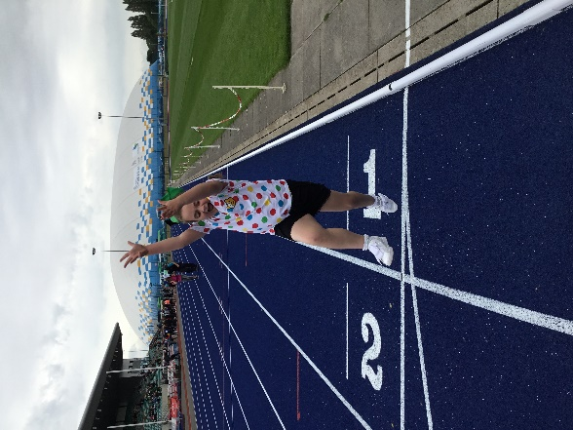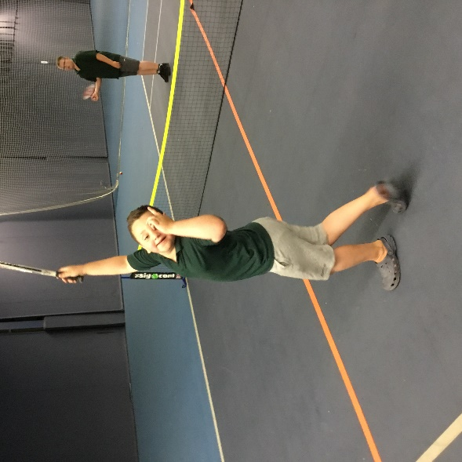

The following policies were adopted by the Governing Body in 2018-19, and are available on the school website (www.ysgolbrynderw.co.uk):

- Accreditation
- Supporting Learners with Healthcare Needs
- Attendance
- Capability
- E-Safety
- Health & Safety
- Intimate Care
- Performance Management
- Positive behaviour management
- Positive Touch
- Safeguarding
- Sex & Relationships Education
- Stress Management
- Total Communication
- Use of Reasonable Force
- Violence at Work

The pupils arrive at Ysgol Bryn Derw, either with families or on Local Authority Transport accompanied by experienced escorts, by 8.55am. They proceed, or are taken by school staff to their classrooms where their teachers are in the classrooms ready to receive them. After the pupils have all been taken to their classrooms, the structure for each school day is as follows: -
9.00 Registration
9.05 Lessons commence
10.30 Break
10.45 Lessons continue
12.00 Lunch
1.00 Lessons continue
3.15 End of School Day
(Pupils transported home – families or Local Authority Transport)

The term dates set by Newport City Council are as follows:

Term | Start | Half-term starts | Half-term ends | Term ends
Autumn | 2 Sept 2019 | 28 Oct 2019 | 1 Nov 2019 | 20 Dec 2019
Spring | 6 Jan 2020 | 17 Feb 2020 | 21 Feb 2020 | 3 April 2020
Summer | 20 April 2020 | 25 May 2020 | 29 May 2020 | 20 July 2020

May Bank Holiday will be on Friday 8th May 2020

There will be 6 closure days for staff In-Service Training (INSET days):

Autumn term INSET days:
Monday 2nd September 2019 – Person Centred Planning
Tuesday 3rd September 2019 – Core Safeguarding
Friday 11th October 2019 – Separate focus for each group of classes on priority areas – e.g. sensory experiences, literacy & numeracy and life skills

Spring term INSET days:
Monday 24th February 2020 – Behaviour management approaches

Summer term INSET days:
Monday 20th July 2020 – Teaching and Learning priorities

The Welsh Government have confirmed an additional INSET day for 2019-20 for all schools in Wales with a focus on the new Curriculum of Wales. If the additional date must be taken in the Summer Term and our date will be confirmed soon.

The first school prospectus is currently being developed

The School are committed to providing access to a broad curriculum for all of our pupils. Alongside this we recognise that the curriculum must be relevant to pupils’ individual needs and there must be in-built flexibility in order to ensure continued relevance for all pupils at the various stages of their time at Ysgol Bryn Derw. This will mean that not all of our pupils will experience all aspects of the curriculum all of the time, but rather that a balance in the whole curriculum will be reflected in pupils’ individual experiences according to the various age related stages of their school life. Balance across the curriculum will also be dictated by the diverse and complex individual needs of our pupils. We recognise that our pupils benefit from a wide variety of sensory activities and the many forms of therapy which are offered to them and that some of our pupils with very challenging behaviours will need an even greater degree of flexibility in their learning and social programmes.

In 2018-19 pupil numbers grew from 47 to 55.

All of our pupils where appropriate, have access to the full range of subjects in the National Curriculum Framework appropriate to their age provided in a way that matches the stage of their development.

The teaching experiences/activities provided and accompanying schemes of work reflect the programmes of study from Foundation Phase, KS2 and 3 of the National Curriculum and for KS4 & 5 accredited units and modules.

The language of the school is designated as English medium

All pupils experience Welsh as an additional language and have incidental Welsh opportunities throughout the school day. Pupils experience Welsh at a level appropriate to their academic and communication skills, and incidental opportunities include greetings, praise, days of the week, numbers, colours, body parts and weather. These will typically be used alongside the English term for the same word. The school has a number of fluent Welsh speaking staff and so is able to offer more sophisticated Welsh language interaction and learning to those who require it. No pupils are dis-applied from any subjects in the National Curriculum
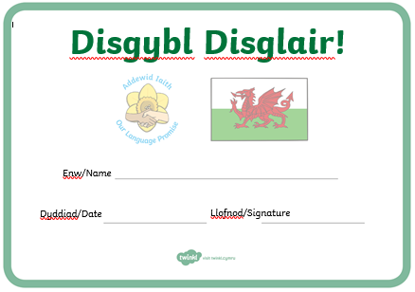

The school has 4 hygiene bathrooms (2 per corridor) with changing beds, toilets and showers. There are also 4 separate sets of toilet cubicles (2 per corridor). All bathrooms and toilets are cleaned daily by Newport Norse and checked throughout the day by staff.

Healthy eating and drinking is an important aspect of the curriculum and experience of all pupils. The approach of the school to eating and drinking is designed to develop:
  - A broadened diet
  - Increased awareness of the impact of diet on health and the human body
  - Improved decision making skills
  - Positive attitudes to health and exercise
  - Increased independence in eating and drinking
The School achieved Level 2 of the Healthy Schools Award in 2018-19. To achieve progress in healthy eating and drinking the school take a ‘whole school/whole day’ approach to the provision of food and drink.

The school provide in partnership:
  - Healthy, nutritious, affordable and attractively presented meals in partnership with NCC catering department and Chartwells.
  - Breakfast Clubs, as far as possible, in line with Welsh Government guidance.
  - Healthy snacks at break times will be encouraged.
  - An enjoyable eating experience in a quality environment.
  - Encouragement for parents to provide healthy lunch boxes.
  - Fresh water, available to all staff and pupils in classrooms
  - Display materials within and around the school that promote the positive relationship between food and physical activity.
  - Engagement with pupils, where appropriate, on healthy food and fitness activities (e.g. Fruit Tuck, Healthy Lunchbox etc.)
  - Procurement and menu planning that recognises the importance of purchasing locally, seasonality, and environmental sustainability in partnership with NCC catering department and Chartwells

