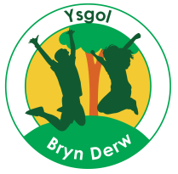
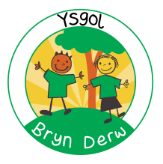

YSGOL BRYN DERW
GOVERNORS
ANNUAL REPORT TO PARENTS
2020-21
FULL REPORT

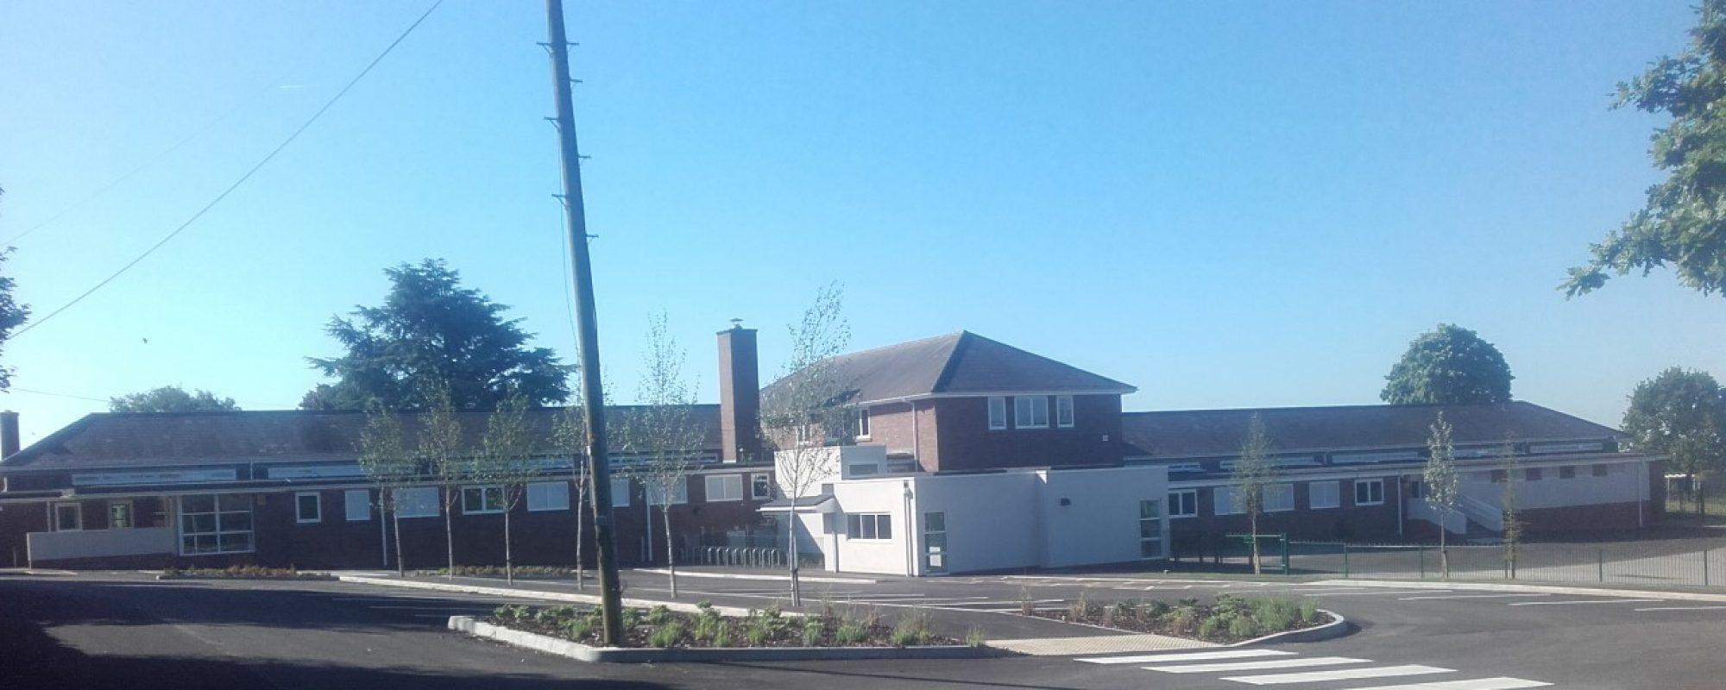

YSGOL BRYN DERW
MELFORT ROAD
NEWPORT
NP20 3FQ

01633 414988

ysgol.brynderw@newportschools.wales

@YsgolBrynDerw17

Dear Parents/Carers
This Annual Report for parents of Ysgol Bryn Derw will provide you with information about yet another extraordinary year in the life of the school.
The conscientious, talented staff have continued to adapt to the circumstances and have provided support and learning opportunities for all learners throughout the COVID pandemic, both in the school building and at home. The whole school staff have risen to the many challenges that lockdown and the pandemic has posed and continue to do so to ensure that Ysgol Bryn Derw continues to be a happy and safe place for all learners.
Our committed Governing Body has continued to work both as a full Governing Body and two sub-committees, meeting on a Wednesday evening every half term. Virtual meetings have worked well and all Governing Body business continues as normal. The Governing Body discuss a broad range of issues at each meeting and provide effective and appropriate scrutiny of the decisions made. I would like to thank all my Governor colleagues for the time and expertise they have given to the school this year, and continue to provide, both in and outside of meetings.
We continue to enhance and improve the buildings and facilities for all learners across the school, all of which you will have read about in various school communications throughout the year. The refurbished annexe building, outside classroom areas and school grounds continue to be developed to provide learners with enjoyable, useful and important new experiences for many years ahead.
Working together has been an essential element throughout the pandemic and I would like to thank all parents, grandparents, family and carers for your continued support and involvement.
Best Wishes,
Paula Halsall
Chair of Governors

YSGOL BRYN DERW – GOVERNORS ANNUAL REPORT TO PARENTS 2019-20

- (& B.)
This is the fourth Governors Annual Report to Parents. No petition for an annual parents’ meeting with Governors was received during the year, and so no meeting was held under Section 94 of the School Standards and Organisation (Wales) Act 2013.

The Governing Body consisted of:

Name | Category of Governor | End of term of office
Paula Halsall | Local Authority | 26/09/21
Nathan Kethro | Local Authority | 11/09/22
Carmel Conn | Community | 15/10/23
Emma Anderson | Community | 16/10/21
Jenna Mellon | Parent (Elected) | 02/07/23
Nikki Chard | Parent (Elected) | 09/10/21
Gwen Vaughan | Parent (Elected) | 09/10/21
Rebecca Forward | Teacher (Elected) | 24/09/24
Kate Drew | Staff (Elected) | 09/10/21
Richard Drew | Head Teacher | n/a

If you wish to contact the Governing Body, the relevant contact details are:

Chair of Governors
Paula Halsall
C/o Ysgol Bryn Derw, Melfort Road, Newport, NP20 3FQ

Clerk to the Governing Body
Clare Williams
C/o Ysgol Bryn Derw, Melfort Road, Newport, NP20 3FQ

There are two current vacancies for Parent Governors and nomination forms are currently in circulation.

Section 52 Statement:

 |  | Ysgol Bryn Derw
 | Financial Statement for Year Ending 31st March 2021
 | 2019/20 |  | 2020/21
 | Outturn |  | Outturn
 | £ | Employees | £
 | 458,039 | Teachers | 507,658
 | 753,595 | Support Staff | 898,199
 | 15,593 | Caretakers | 26,129
 | 0 | Midday Supervisors | 0
 | 0 | Cleaners | 0
 |  | Other Employee Costs
 | 38,758 | Supply Insurance Premium | 525
 | 60,123 | Agency Staff | 74,322
 | 0 | Lunch Time Meal Entitlement | 0
 | 0 | Foreign Language Assistants | 0
 | 0 | Exam Invigilators | 0
 | 631 | Advertising | 1,259
 | 0 | Interview Expenses | 0
 | 1,094 | Misc Employee Costs | 966
 |  | Energy
 | 6,888 | Gas | 6,483
 | 5,680 | Electricity | 8,479
 | 0 | Oil | 0
 | 32,415 | Capitation and ICT | 36,763
 | 11,191 | SCC, EIG and PDG Expenditure | 0
 |  | Premises Related
 | 3,102 | Hire of Facilities | 911
 | 573 | Rates | 0
 | 10,542 | Building Maintenance and Alarm Lines | 77,032
 | 4,108 | Grounds Maintenance | 3,897
 | 2,255 | Water | 3,293
 | 21,493 | Building Cleaning Contract | 26,347
 | 1,360 | Refuse Collection | 1,578
 | 6,543 | Miscellaneous Premises | 17,971
 |  | Communications
 | 53 | Postage/Fax/Telex | 248
 | 779 | Telephones | 0
 |  | Transport
 | 21,631 | Vehicle Maintenance | 92
 | 0 | Purchase of Vehicles | 0
 | 522 | Vehicle Hire | 0
 | 668 | Car Allowance | 29
 | 105 | Travel Expenses | 269
 | 0 | Exam Fees | 0
 |  | External Courses
 | 12,055 | School Funded Training | 16,719
 | 0 | Alternative Curriculum Provision | 0
 | 0 | Sixth Form | 0
 | 23,323 | Central Services | 25,438
 |  | Income
 | -300 | Lettings | 0
 | -5,325 | Sales Income | -2,599
 | 0 | Music Service Income | 0
 | -650 | Donations | -16,574
 | -1,708 | Miscellaneous | 0
 | -11,794 | Supply | -519
 | 0 | Exam Fees | 0
 | -441 | Interest | -745
 | 0 | Rental Income | 0
 | 0 | EIG | 0
 | 0 | PDG/EYPDG | 0
 | 0 | Energy Compensation | 0
 | 0 | Coaching Fees | 0
 | -74,591 | Other Grant and Contributions | -237,429
 | 0 | Reserve Transfer | 0
 | 0 | After Schools Club | 0
 | 1,398,310 | Total Net Expenditure | 1,476,741
 | 1,447,323 | Total Funding | 1,576,272
 | 49,013 | In Year Surplus / Deficit | 99,531
 | 63,904 | Prior Year Surplus / Deficit | 112,917
 | 112,917 | Accumulated Surplus / Deficit c/fwd | 212,448
 | 7.80% | Balance as % of Funding | 13.48%

The total funding received in 2019-20 was £1,834,138, made up of a £1,576,272 budget share allocated by NCC, and £257,866 in additional NCC funding for increased pupil numbers. Welsh Government grants, donations from parents and businesses, and income from training courses and lettings.

The budget was spent as follows:
Approximately 83% of the budget was spent on staffing costs.
Approximately 4% of the budget was spent on supply staff to cover long-term vacancies, ad hoc staff sickness, and planned staff absences due to training courses.
Just over 2% of the budget was spent on supplying the school with the required furniture and equipment, general classroom and stationery supplies, ICT equipment (such as laptops, iPads, iPods and some required ICT licences), and photocopier charges.
Approximately 7% of the budget was spent on premises related costs, including: repairs and general maintenance; insurance and required licences; cleaning and hygiene supplies; improvements to the security system; work carried out by Newport Norse to improve our environment.
Approximately 1% of the budget was spent on energy costs.
Approximately 1% of the budget was spent on staff training (e.g. PECS, Intensive Interaction).
Just over 1% of the budget was allocated to required Service Level Agreements with Newport City Council (e.g. Finance, HR, Legal Services, and Health and Safety).

A 13.48% surplus (£212,448) was carried forward to undertake improvement projects delayed by the second lockdown, to accommodate rising pupil numbers and associated staffing and equipment costs in 2021-22.

We did not receive any gifts in 2018-19 (aside from monetary donations listed above).

No travel and subsistence claims were made by members of the Governing Body in 2020-21.

There were two Year 11 pupil in 2020-1, and both pupils stayed at Ysgol Bryn Derw.

The school has links with the Community which have brought considerable benefits to pupils and helped them to develop their communication, interaction and independence, whilst COVID restrictions have limited access we have sought to maintain links. Previous links have included:

  - Visits to local Baptist Church
  - Visit from Fire Service
  - Visits from professional partners including Speech and Language Therapists, Occupational Therapists, Learning Disability Nurses, Educational Psychologists, Counsellors and Music Therapists
  - Visits from Keep Wales Tidy
  - Shopping at Local Shops, Tesco
  - Visits to Stelvio Park & Serennu Park
  - Gaer Primary School for inclusive partnerships
  - Participation in a Dance Festival
  - Visits to Theatre and Cinema
  - Visit to St Fagan’s Museum
  - Leckwith Stadium for ‘Welsh Sports Association For People With Learning Disabilities’ Athletics competitions
  - Entry to Welsh Schools Heritage Initiative competition
  - Spytty Park for Tennis taster sessions
  - Risca Leisure Centre & NISV for swimming
  - Raising funds for charities including Children in Need and Macmillan Coffee Morning

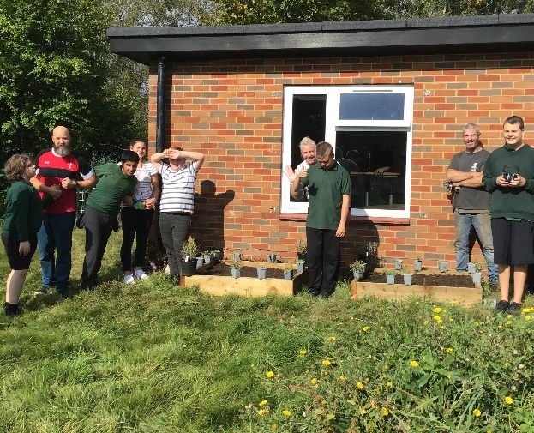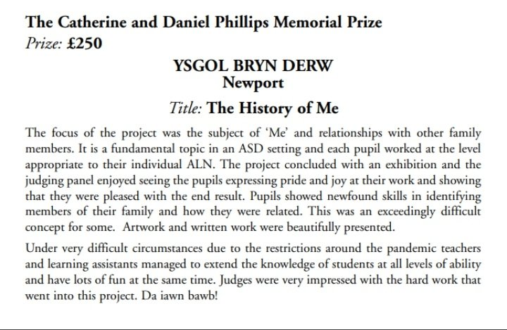

Targets for attendance for 2021-22 have been set:
 | 2021-22 targets
Overall | 93%
Primary | 93%
Secondary | 93%

The key foci of the School Development Plan for 2021-22 have been agreed and are:
1. Maintain outcomes for vulnerable groups, raise progress in Language & Literacy and ensure all 16-19 aged pupils access awards at appropriate levels
2. Maintain and enhance strong levels of pupil wellbeing, embedding new Engagement Profile mechanism
3. Continue to strengthen curriculum planning to meet the needs of pupils as they move through the school, and improve consistency of class-based enhanced provision
4. Embed recently appointed intervention roles to maximise impact upon key areas of challenge for pupils and families
5. Ensure Kimberley building is staffed, resourced and equipped to an equivalent standard to main site and provides high quality bespoke provision for Foundation Phase learners

Physical Education is an important aspect of the curriculum and experience for all pupils. PE and sporting activities are designed to develop the following:
- Improved Fine and Gross Motor Skills
- Increased self-confidence and self-esteem
- Improved skills in listening and following instructions
- Positive attitudes to health and exercise
- Mature approaches to competition and to winning and losing
All pupils participate in specially designed PE lessons every week. Relevant pupils have access to Rebound Therapy with specially trained staff each week. Due to the lockdown we were unable to hold a full sports day in 2020-21, however a week of activities was held in July in class groups. We were unable to attend swimming lessons or the heats and finals with the Welsh Sports Association for People with Learning Difficulties, and the Dance Festival at Penycwm School was also postponed.

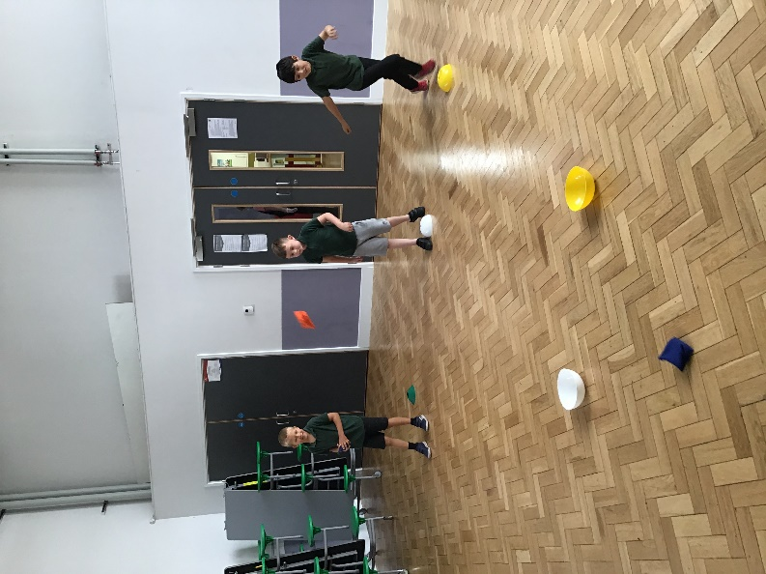
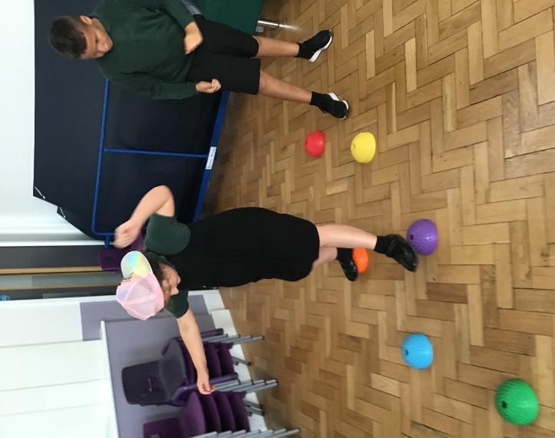

The following policies were adopted by the Governing Body in 2020-21, and are available on the school website (www.ysgolbrynderw.co.uk):

- Supporting Learners with Healthcare Needs
- Anti-bullying
- Complaints
- Teaching & Learning Policy
- Whole School Curriculum
- Traffic Management
- Positive Touch
- Charging for School Activities
- Sex and Relationships Education
- Relationships Policy

The pupils arrive at Ysgol Bryn Derw, either with families or on Local Authority Transport accompanied by experienced escorts, by 8.55am. They proceed, or are taken by school staff to their classrooms where their teachers are in the classrooms ready to receive them. After the pupils have all been taken to their classrooms, the structure for each school day is as follows: -

9.00 Registration
9.05 Lessons commence
10.30 Break
10.45 Lessons continue
12.00 Lunch
1.00 Lessons continue
3.15 End of School Day
(Pupils transported home – families or Local Authority Transport)

The term dates set by Newport City Council are as follows:

Term | Start | Half Term Starts | Half Term Ends | Term Ends
Autumn | Thursday  2 Sept 2021 | Monday  25 Oct 2021 | Friday  29 Oct 2021 | Friday  17 Dec 2021
Spring | Tuesday  4 Jan 2022 | Monday  21 Feb 2022 | Friday  25 Feb 2022 | Friday  8 April 2022
Summer | Monday  25 April 2022 | Monday  30 May 2021 | Friday  3 June 2022 | Friday  22 July 2022

May Bank Holiday will be on Monday 2nd May 2022

Closure in lieu of the Queen’s Platinum Jubilee Bank Holiday will be on Friday 27th May 2022

Additional school closure dates:

Autumn term INSET days:
Thursday 2nd September 2021 – Core Safeguarding
Friday 3rd September 2021 – Core Safeguarding
Monday 6th September 2021 – Person Centred Planning

Spring term INSET days:
Tuesday 4th January 2022 – Engagement & Communication

Summer term INSET days:
Monday 25th April 2022 – Curriculum for Wales (Inc Gina Davies Institute)
Friday 22nd July 2022 – Outdoor Learning & Continuous Provision

The school prospectus can be found in the following location http://ysgolbrynderw.co.uk/wp-content/uploads/2019/11/Prospectus-August-2019.pdf

The School is committed to providing access to a broad curriculum for all of our pupils. Alongside this we recognise that the curriculum must be relevant to pupils’ individual needs and there must be in-built flexibility in order to ensure continued relevance for all pupils at the various stages of their time at Ysgol Bryn Derw. This will mean that not all of our pupils will experience all aspects of the curriculum all of the time, but rather that a balance in the whole curriculum will be reflected in pupils’ individual experiences according to the various age related stages of their school life. Balance across the curriculum will also be dictated by the diverse and complex individual needs of our pupils. We recognise that our pupils benefit from a wide variety of sensory activities and the many forms of therapy which are offered to them and that some of our pupils with very challenging behaviours will need an even greater degree of flexibility in their learning and social programmes.

In 2020-21 pupil numbers grew from 69 to 73

All of our pupils where appropriate, have access to the full range of subjects in the National Curriculum Framework appropriate to their age provided in a way that matches the stage of their development.

The teaching experiences/activities provided and accompanying schemes of work reflect the programmes of study from Foundation Phase, KS2 and 3 of the National Curriculum and for KS4 & 5 accredited units and modules.

The language of the school is designated as English medium

All pupils experience Welsh as an additional language and have incidental Welsh opportunities throughout the school day. Pupils experience Welsh at a level appropriate to their academic and communication skills, and incidental opportunities include greetings, praise, days of the week, numbers, colours, body parts and weather. These will typically be used alongside the English term for the same word. The school has a number of fluent Welsh speaking staff and so is able to offer more sophisticated Welsh language interaction and learning to those who require it. No pupils are dis-applied from any subjects in the National Curriculum
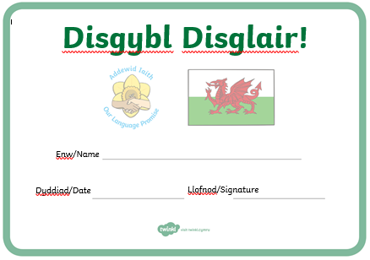

The school has 4 hygiene bathrooms (2 per corridor in the main building) with changing beds, toilets and showers. There are also 5 separate sets of toilet cubicles (2 per corridor and 1 in the Annex building). All bathrooms and toilets are cleaned daily by Adapt Commercial Cleaning and checked throughout the day by staff.

Healthy eating and drinking is an important aspect of the curriculum and experience of all pupils. The approach of the school to eating and drinking is designed to develop:
  - A broadened diet
  - Increased awareness of the impact of diet on health and the human body
  - Improved decision making skills
  - Positive attitudes to health and exercise
  - Increased independence in eating and drinking

The School has achieved Level 3 of the Healthy Schools Award. To achieve progress in healthy eating and drinking the school take a ‘whole school/whole day’ approach to the provision of food and drink.

The school provide in partnership:
  - Healthy, nutritious, affordable and attractively presented meals in partnership with NCC catering department and Chartwells.
  - Breakfast Clubs, as far as possible, in line with Welsh Government guidance.
  - Encouragement of healthy snacks at break times.
  - An enjoyable eating experience in a quality environment.
  - Encouragement for parents to provide healthy lunch boxes.
  - Fresh water, available to all staff and pupils in classrooms.
  - Display materials within and around the school that promote the positive relationship between food and physical activity.
  - Engagement with pupils, where appropriate, on healthy food and fitness activities (e.g. Fruit Tuck, Healthy Lunchbox etc.)
  - Procurement and menu planning that recognises the importance of purchasing locally, seasonality, and environmental sustainability in partnership with NCC catering department and Chartwells.

